*High End Hammy Downs*

Requirements:

**Website or Mobile App**

Contents

1 Document Details 3

1.1 Document History 3

1.2 Blackbook Contact Details 3

1.3 Client Contacts 3

1.4 Document Sign-Off 3

2 Background 4

3 Out of Scope 4

4 Client Requirements 5

4.1 General Requirements 5

4.1.1 Design Requirements 5

4.1.2 General Functional Requirements 5

4.2 Pre-Existing Data 6

4.3 Alerts and Emails 6

4.4 Modules and Wireframes 7

4.4.1 Login Page 7

4.5 Error Handing & Exceptions 22

5 Appendix 23

5.1 Supporting Documentation 23

5.2 Acronyms 23

# Document Details

## Document History

The purpose of this document is to provide business requirements and certain design specifications to deliver a more functional web solution for High End Hammy Downs

This document is for internal use only, and any uncertainties have been clarified with the client.

Any specifications or requirements outside of this document will be considered out of scope or trigger the change request process.

|  |  |  |  |
| --- | --- | --- | --- |
| Version | Date | Author | Comments |
| 0.1 | 20/07/22 | Natasha Lam | Initial Draft Requirements |
|  |  |  |  |

## Blackbook Contact Details

If you have any enquiries and proposed changes regarding this document, please contact:

Name: Quang

Role:

Email:

## Client Contacts

|  |  |  |
| --- | --- | --- |
| Name | Position | Email |
| Natasha Lam | Owner | highendhammys@gmail.com |

## Document Sign-Off

|  |  |  |
| --- | --- | --- |
| Name | Date | Link to Approval Email |
|  |  |  |
|  |  |  |

# Background

High End Hammy Downs is an online clothes swapping tool for parents. Parents are matched by entering their children’s clothing criteria, once matched, and connected, they can start swapping. Swapping your kids outgrown clothes is not just economical, it’s a sustainable option for second hand clothing. The existing website has attracted over 100 customers.

High End Hammy Downs is seeking a more intelligent web or app, that will automate the matching and connecting of parents. Currently the questionnaire data on the website sits in a wix form, that is downloaded to excel on a regular basis and is matched manually. Customers are matched by postcodes (location), size of clothes, gender of clothes and style of clothes.

Once a match is made, I directly contact each “Giver” and “receiver” via email to get approval to swap, show them photos of the clothes, and organise an appropriate swapping location (e.g local library). They swap the clothes and then wait for another match or match again next year when their kids have grown out of those clothes. The solution will also need to introduce the swappers, give them an option to accept or decline after seeing the photos.

Screen shot below is the form that collects the data from the questionnaire, which creates the customer profile

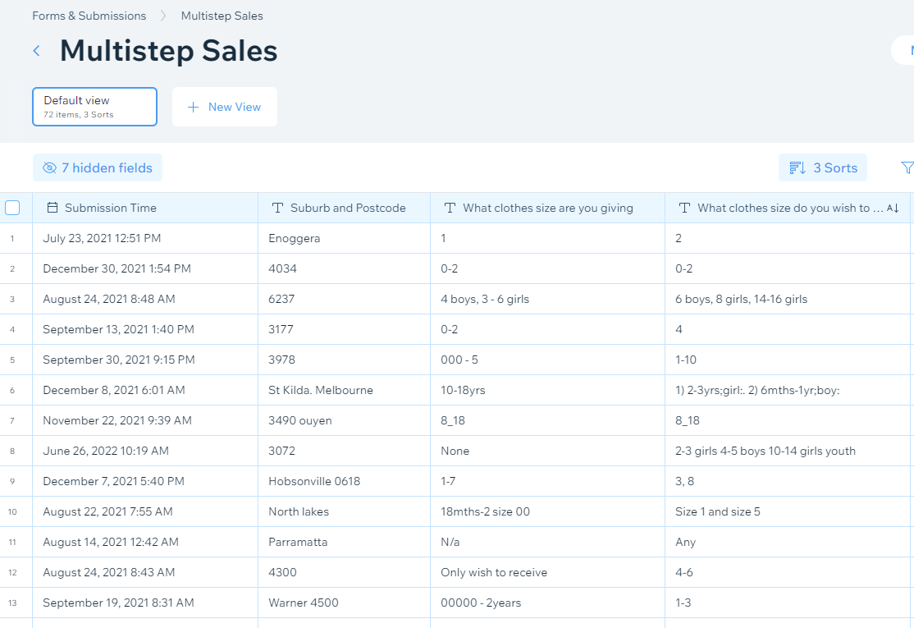

Currently the membership is free, however the memberships will now be split into Basic (free membership) and Premium (paid membership).

# Out of Scope

The following items are out of scope and recommended as phase 2:

* Chat functionality between customers
* Sending calender invites between customers
* School Uniform swap

# Client Requirements

General Requirements

The following requirements have been compiled based on the initial website and discussions with the Project Manager (PM) and relevant SME(s).

### Design Requirements

* Branding kept and can be applied to the solutions UI.

### General Functional Requirements

* Clicking on the logo will return the user to the Home Page.
* School Uniform match page to be removed (phase 2)
* T&C/FAQ page to be retained
* About page to be retained
* Membership option of Basic or Premium (paid), with existing Wix website Stripe is currently used as payment collection. Continue to use Stripe.
* Paid membership (Premium) will have the following benefits
  + Free postage
  + Free swapping bag
  + High end brands only being swapped
  + Browse matches – various types of matches listed below
  + Unlimited kids
  + Photos must be loaded
* When customer is signing up, all their details create their profile, which they are able to update anytime when logged in.
* Customers enter ‘Receiving clothes’ criteria and ‘Giving clothes’ criteria, ‘Giving clothes’ criteria must have an upload function, where customers can upload up to 3 photos of clothes they are giving.
* Once criteria is entered, this criteria needs to be matched with all other criteria that’s been entered so far to date, to identify if there is a match in criteria with existing members that have not been matched yet.
* There are several types of matches for Premium;
  + Perfect Match – matches all criteria given either in ‘Receiving’ Or ‘Giving” criteria
  + Happy Hammy Match – matches everything but ‘swapping method’
  + Mini Match – matches everything but ‘swapping method’, Style and Number of items
  + Long Distance Match – Matches everything but Location (postcode)
* If there are no matches after signing up, then a button needs to pop up and ask if they would like to be notified when we have found a match. This means we need to prompt the matching process 1-2 times a week to rematch those that have already signed up with new matches from that week. Then send an email with a new match notification.
* If there is a match instantly for example to Receive clothes, then they can be directed to their profile where a Matches page is available, they are able to view the pictures uploaded from the Giver and Decline or Accept the match. If they Accept the Giver is sent the receivers email address and connection is made.
* Once a match is made, customers need to be prompted a few weeks later via email, to check that the swap has taken place, and they either need to update their swapping profile on the web page, to ‘Active” or ‘Not Active’ or change sizes or ‘Not swapping right now’.
* Swaps can be archived into their profiles, so they have a history of what they have swapped
* On the webpage, can we have a running tally of current swaps, and pictures of current swaps. For example once a swap is made and confirmed, that picture that was uploaded can appear on the ‘Featured Swaps’ Page
* Do customers give permission to exchange email addresses immediately once a match is secured or prefer and wait to see how your match is. This can be done, by viewing the photos of the giver, and accept of decline will come up in the profile. Navigate to her from email notification.
* In profile, profile history can form apart of the Sustainability Stats page, which will be in every profile. This will calculate, how much water was saved, how many kg of clothes were diverted rom landfill and greenhouse gases avoided. This data is sourced from the number of clothes swapped.
* If Postal option is selected, once a match is made they will need to add their postal address into their profile, so the giver can send them the clothes.
* Postal option – directs to Aust Post page to generate a label Or I just continue to do manually for now until integration with postal third-party is worked out.

Pre-Existing Data

* Wix already stores existing data of members for approx. 100 customers. This is exported to excel for manual matching (the current process) – see Appendix

Alerts and Emails

* An email notification needs to be sent to ‘Giver’ and “receiver’ when there is a match.
  + The ‘Receiver’ is sent an email first with the photo of the ‘Givers’ Clothes, if they want to accept, then an email is sent to the ‘Giver’ confirming a match.
  + The ‘Giver’ then receives the confirmation, in that confirmation is the email address of the ‘Receiver’. The “Giver’ then connects and organise a time and place to meet.
* An email notification is sent one week after there is a match with the “Giver”. The email needs to confirm the match has taken place and directs the “Giver” to update their status and their swaps on the platform. This advice can also be sent in the original match email. This is to ensure, we don’t make matches that have already been matched
* An email notification is sent one week after there is a match with the ‘Receiver”. This email needs to confirm the match has taken place and directs the “Receiver” to update their status and their swaps on the platform. This advice can also be sent in the original match email. This is to ensure, we don’t make matches that have already been matched. However in the “Receivers” case they can choose still to receive clothes again with the same criteria if they wish.

## Modules and Wireframes

### Login Page

The following wireframes show the log in page. This is the first page the user is presented with when navigating to the portal. The following specifications apply to this page:

* If a user forgets their password, they can select Forgot Password? and a request to reset the password is sent somewhere – guided by general practice.

#### General View

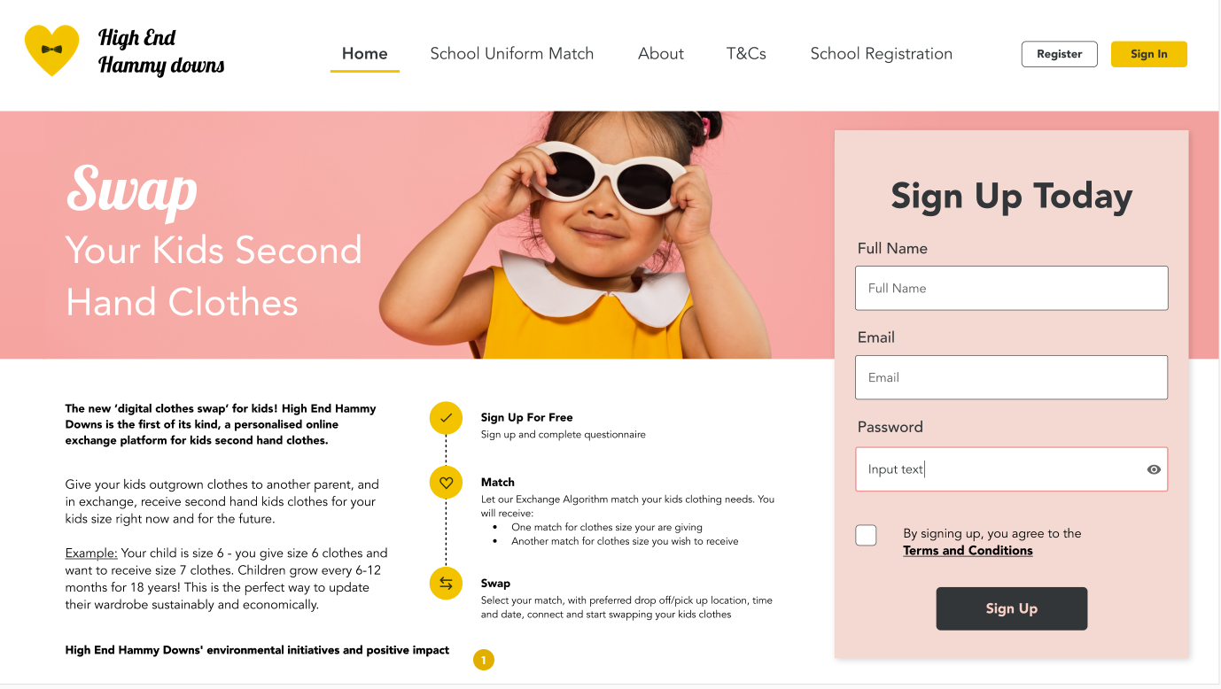

#### Signing Up and creating profile

Receiving Criteria

Giving Criteria

#### Finding a Match

#### Connect with Matches

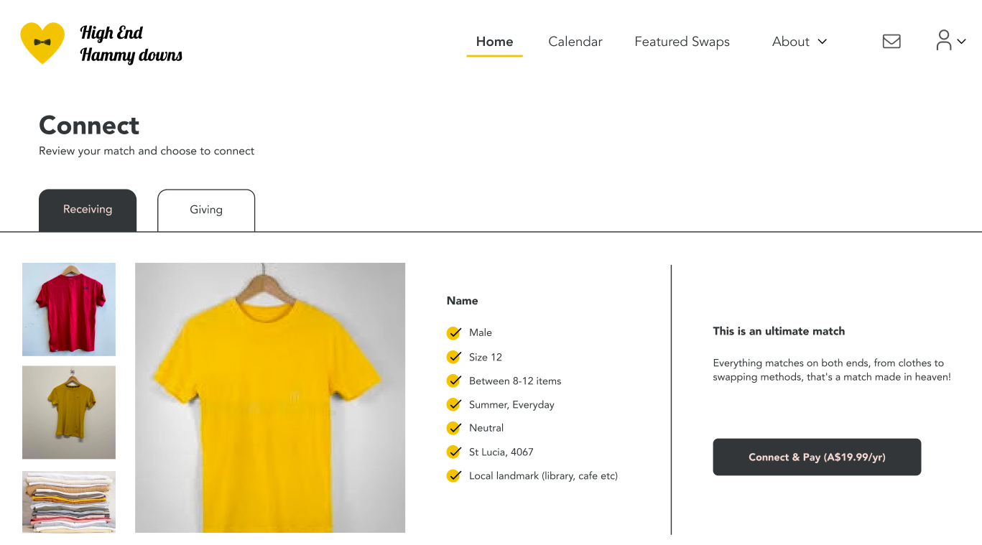

To connect with matches, a notification will be emailed to the ‘Receiver’, it will have a link to log into the portal, in the portal they will see the match and the pictures the ‘Giver’ has uploaded. It will have a button, do you want to accept the match Yes or No. Once accepted the ‘Giver’ will be notified that there is a receiving match to receive the clothes they are giving. In that email will be the receivers email address for the Giver to make an appropriate time to meet and swap clothes.

Once swapped, the ‘Giver’ should receive a notification a few weeks after the match has been made to follow up to see if the Giving customer need to archive their swap.

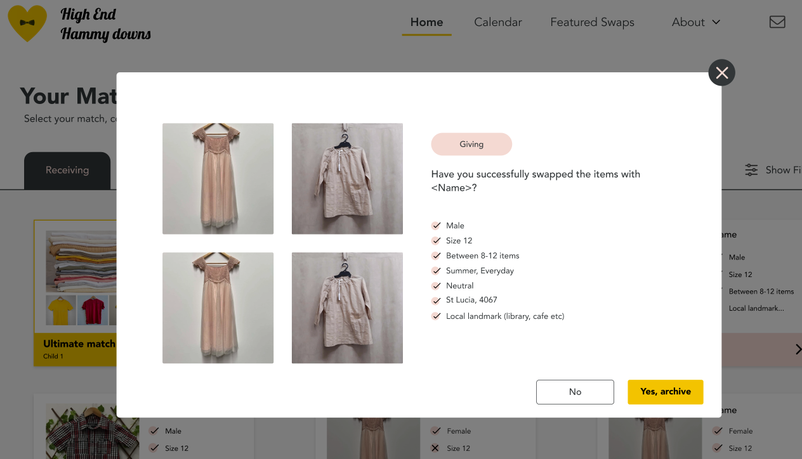

If it wasn’t swapped, we are asking for feedback as to why.

Once matches have been matched and archive, customers will see this screen below if they have no active swaps.

#### Profile tabs

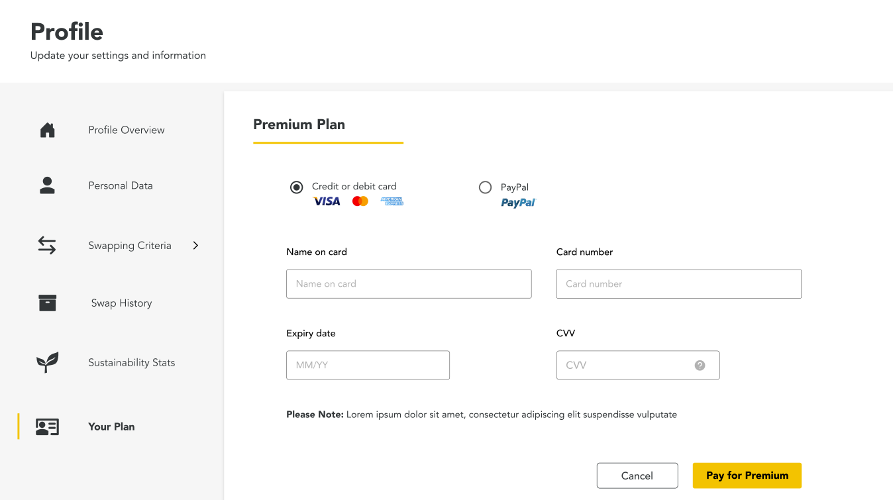

#### Featured swaps pages

For customers to view current swaps – which will be curated by me to place here so everyone can see.

#### Forgot Password? Is clicked

Need to allow for

#### Incorrect Credentials

Need to allow for

Error Handing & Exceptions

|  |  |
| --- | --- |
| Error | Outcome |
| Incorrect file format for uploading photos | Notification: “*The file format you have uploaded is invalid. Please upload a valid file format”* |

# Appendix

Supporting Documentation

|  |  |
| --- | --- |
| Item | Location/Insert Document |
|  |  |
|  |  |
|  |  |
|  |  |
|  |  |

## Acronyms

|  |  |
| --- | --- |
| Acronym | Description |
| SME | Subject Matter Expert |
| PDD | Process Deep Dive |
| SDD | Solution Design Document |
| PBD | Post Build Document |